# Lab Number: 04 Date: 2025/07/04

# Title: Static IP Setting on Windows/Linux Machine using GUI and Command Prompt

**THEORY:**

1. **IP Address (Internet Protocol Address)**

An IP address, or Internet Protocol address, is a unique numerical identifier assigned to every device connected to a computer network that uses the Internet Protocol for communication. Think of it like a postal address for your computer, allowing data to be sent and received across the internet. IP addresses enable devices to locate and communicate with each other, ensuring that information reaches its intended destination. They are essential for routing data packets and are a fundamental part of how the internet functions. There are two main types of IP addresses: Static IP Address and Dynamic IP Address.

1. **Static IP Address**

A Static IP is an IP address that is manually assigned to a device and does not change over time. With a static IP, external devices can always connect to the same address, making it crucial for applications like hosting websites, running email servers or establishing VPN connections. However, static IP are typically more complex to set up and manage, and they are more susceptible to security risks since they are always known and do not change. A fixed IP addresses streamlines network setup and administration by providing consistency and is ideal for networks where devices must be easily identified and reachable.

1. **Dynamic IP Address**

A dynamic IP address is an IP address that changes periodically, unlike a static IP address which remains constant. Internet Service Providers (ISPs) often assign dynamic IP addresses to residential customers because it's a cost-effective way to manage their pool of available IP addresses. When a device connects to a network, it's assigned an IP address from a pool, and that address may be reassigned to another device later. Dynamic IP addresses offer several advantages, primarily related to cost, security, and ease of management.

1. **Subnet Mask**

A subnet mask is a 32-bit number that divides an IP address into network and host portions, enabling efficient network routing. It acts like a filter, telling devices how to interpret an IP address and whether a destination is on the same local network or a remote one. By separating the network and host portions, subnet masks allow for the creation of smaller, more manageable subnets, improving network performance and organization.

**Example:** Subnet Mask: 255.255.255.1

1. **Default Gateway**

A default gateway acts as a router, enabling communication between devices on a local network and external networks, like the internet. It's the designated exit point for a network, directing traffic to its destination when the destination is not within the same network segment. Essentially, it's the address a computer uses as a default route to reach other networks. Without a default gateway, devices on different networks wouldn't be able to communicate with each other or access the internet.

**Example:** Default Gateway: 192.168.1.1

1. **DNS Server (Domain Name System Server)**

A DNS Server is responsible for translating human-friendly domain names (like www.example.com) into IP addresses that computers use to identify each other on the network. When you type a website address into your browser, the DNS server looks up the corresponding IP address so that your request can be routed to the correct server. DNS servers are essential for the usability of the internet, as they allow users to navigate online using easy-to-remember names rather than complex numeric IP addresses.

**Example:** DNS Server 8.8.8.8 (Google’s public DNS server)

1. **Static IP Configuration on a Windows Machine using GUI**

**Step 1: Firstly, Check Network Information Before IP configuration:**

* 1. Also, we check network connectivity using ‘ping’ command to test connectivity with the gateway and external sites
  2. 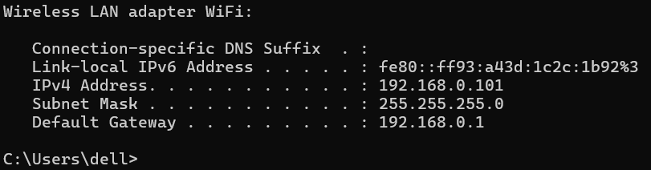To ensure proper connectivity, the ping command is used to test communication between the device and external servers.

Fig: Default Network Information

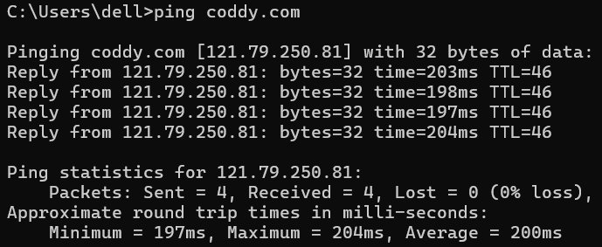

Fig.: Network connectivity of Coddy’s server

**Step 2: Open Network and Sharing Center:**

* 1. Click on Start or Windows and then search Control Panel. And open the Control Panel
  2. 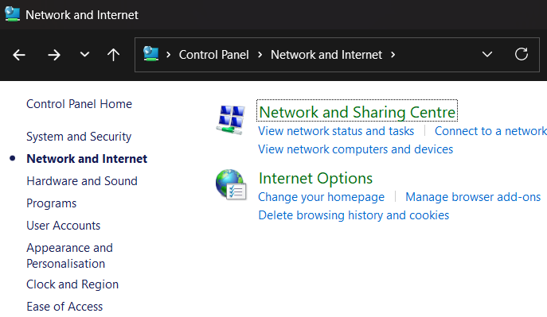Navigate to Network and Internet. After that, go to Network and Sharing Center.

Fig.: Network and sharing center in control panel

**Step 3: Access Adapter Settings**

3.1 Click on Change adapter settings in the left pane.

3.2 Right-Click on the desired network connection and select Properties.

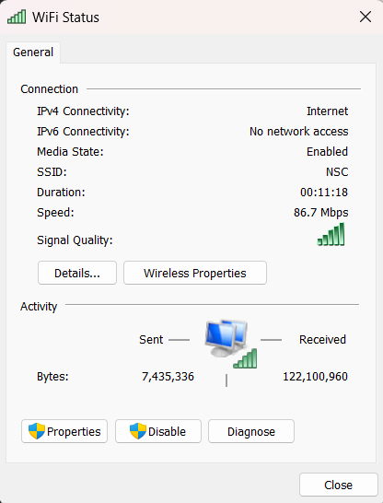

Fig: Network selection on Adapter settings

**Step 4: Configure IPv4 Settings**

4.1 Select Internet Protocol Version 4 (TCP/IPv4) and click Properties.

4.2 Choose Use the following IP address and input the following details:

IP Address: 192.168.18.100

Subnet Mask: 255.255.255.0

Default Gateway: 192.168.18.1

4.3 Enter the DNS server address:

Preferred DNS server: 8.8.8.8

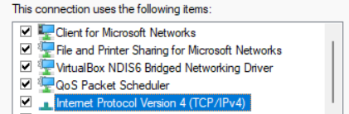

Fig: Selecting IPv4 for configuration

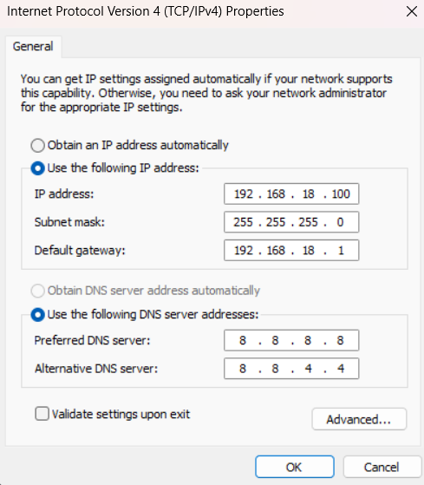

Fig: Configuring iPv4 address

**Step 5: Save and Verify**

* 1. Click OK to apply and save the settings
  2. Execute ‘ipconfig’ command in command prompt to verify that the static IP address is configured correctly.

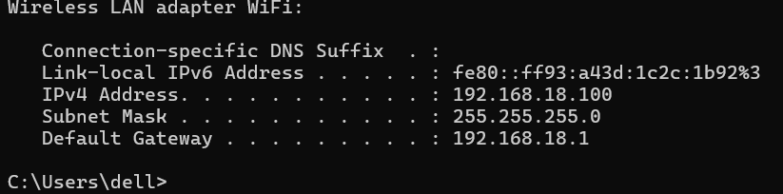

Fig: Default network information after Static IP configuration

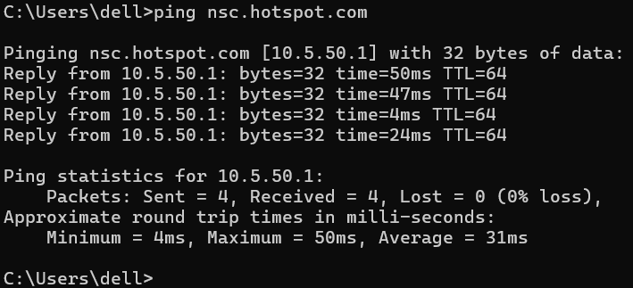Checking network connectivity after Static IP configuration using ‘ping’ command to test connectivity with the gateway and external sites.

Fig: Network connectivity of nsc hotspot’s server

1. **Static IP configuration Using Command Prompt (CLI)**

**Step 1: First, Test the Device’s Connectivity and IP:**

1.1 Here, we see the default or current DNS, IPv4 Address as 192.168.0.101, Subnet Mask as 255.255.255.0 and Default Gateway as 192.168.0.1.

fig.: Default Network Information

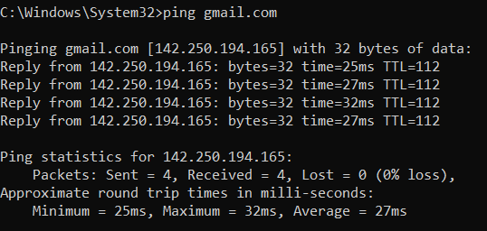

fig: Checking network connectivity of email’s server using “ping”

**Step 2: Get Network Interface Name**

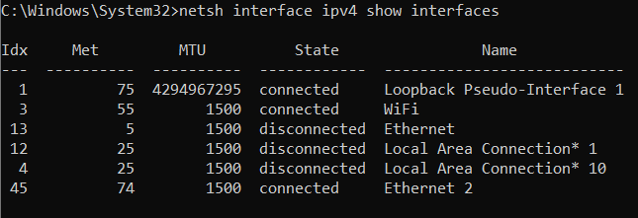**Syntax**: *netsh interface ipv4 show interfaces*

**Step 3: Set Static IP**

**Syntax**: *netsh interface ip set address name="WiFi" static 192.168.1.100 255.255.255.0 192.168.1.1*

Fig.: Setting Wireless LAN Static IP

**Step 4: Set DNS Servers**

**Syntax:** *netsh interface ipv4 set dnsservers "WiFi" static 8.8.8.8 validate=no*

fig.: Setting both DNS through alternative method

**Step 5: Verifying Configuration:** After we change the Static IP Configuration with the help of Command Line Interface (CLI) using above network commands, we can see that IPv4 Address changed from 192.168.0.101 to 192.168.1.100 and Default Gateway from 192.168.0.1 to 192.168.1.1 in below figure.

To verify that we use the following syntax:

**Syntax:** *ipconfig/all*

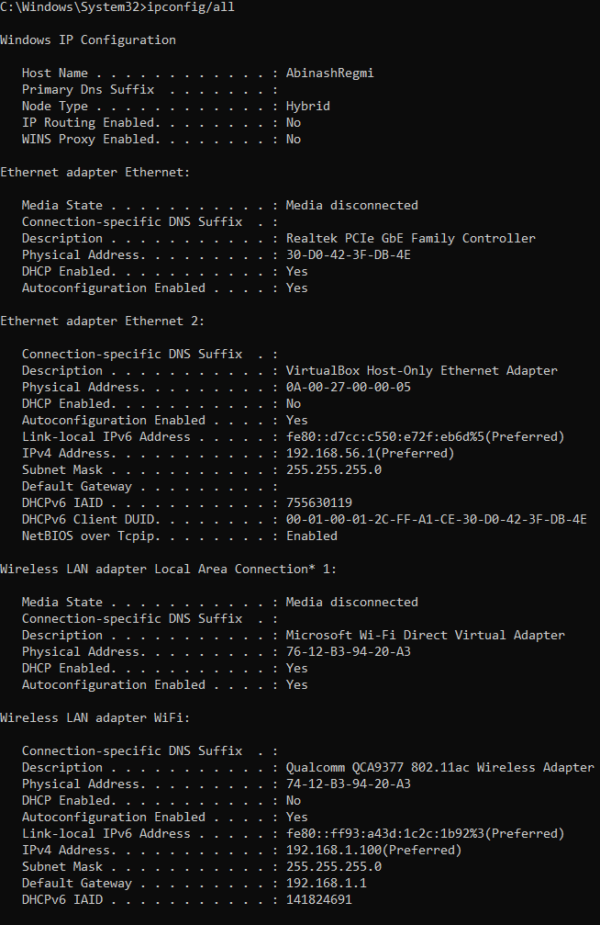

Fig.: Verifying Configuration

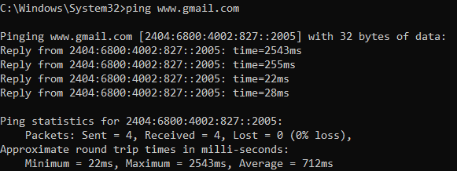

Fig.: Network connectivity of Gmail’s server

**Conclusion**

In this lab, we effectively set up static IP addresses on both Linux and Windows systems. Static Ips are essential for ensuring stable network communication, particularly for devices that offer services needing a fixed address. The lab provided a thorough demonstration of how to configure and verify static IP settings, enhancing our grasp of network configuration processes. By practicing these steps, we gained valuable experience in managing network settings, which is crucial for troubleshooting and optimizing network performance in real-world scenarios. This hands-on approach reinforced our understanding of how static IPs contribute to network reliability and consistency.